Mission: “To minimize harm to lives, property, and infrastructure from severe weather events and tsunamis."

Triz 9 boxes:
We defined the triz 9 boxes by searching online for the history of the system as well as our prior knowledge.
Timeline | Past (5 years) | Present | Future (5 years)
Super System | - Fragmented disaster warning infrastructure  - Independent meteorological and seismic monitoring agencies  - Manual coordination between emergency services  - Traditional one-way communication channels (TV, radio)  - Reactive response systems with delayed warnings  - Limited public access to real-time data | - Integrated disaster preparedness and response ecosystem  - Coordinated multi-agency networks (government, emergency responders, scientific community)  - Real-time data sharing platforms  - Multi-channel alert systems (SMS, apps, government networks)  - Machine learning-enhanced prediction capabilities  - Public as active stakeholders receiving actionable insights | - AI-driven global resilience network  - Autonomous prediction and response coordination  - Smart city integration with automated protocols  - Communal, location-based risk profiling (community)  - Seamless collaboration with other systems on a global scale.  - Predictive modeling influencing infrastructure planning  - Urban planners, policymakers, meteorologists and other researchers (scientific purposes)
System Functionality | - Detect basic weather and ocean conditions (temperature, pressure, wind, sea level).  - Identify large-scale seismic activity that could indicate tsunamis.  - Provide basic forecasts for storms and tsunami likelihood using historical patterns.  - Share general warnings after detection (often delayed).  - Classify events broadly (e.g., storm category, tsunami alert level). | - Sense detailed atmospheric and oceanic changes with higher frequency and coverage.  - Detect early signs of severe storms and underwater disturbances.  - Predict severity and impact zones with moderate confidence using integrated data.  - Deliver timely, reliable, and actionable alerts tailored to risk level.  - Assess dynamic risk based on severity and exposure. | - Continuously sense fine-scale changes across multiple environments.  - Anticipate complex patterns like combined storm and tsunami triggers.  - Predict cascading effects and compound hazards with high confidence and adaptive models.  - Provide proactive, context-aware information for different decision horizons (minutes, hours, days).  - Evaluate complex trade-offs and cascading impacts for better prioritization.
Sub-System requirements | - Basic stand-alone sensors (pressure gauges, seismometers, rainfall meters)  - low-resolution satellite feeds  - Manual data logging and collection equipment  - Separate meteorology and seismic computing platforms  - Single-purpose communication hardware (radio transmitters, sirens)  - Limited processing algorithms (simple threshold detection, no ML)  - No centralized integration of sensor outputs | - Satellite imaging units  - Aircraft-based atmospheric sensors  - Underwater seismic & pressure sensors  - ML-enhanced analytics  - Real-time data fusion algorithms  - SMS / mobile app integration  - API for government networks  - Cloud-based storage & distributed databases  - System health & diagnostics module  - User interface dashboards for authorities and researchers  - Power and redundancy subsystem (UPS, backup comm links) | - Autonomous self-calibrating sensors  - nano-sensors, self-healing or self-diagnosing units  - AI-driven decision engine  - autonomous threat classification  - reinforcement learning for prediction refinement  - Edge computing at sensor level (processing near the sensor to reduce latency)  - Distributed sensor mesh networks  - sensors communicating collaboratively  - Satellite–UAV hybrid swarm surveillance  - Automatic detection of sensor failures and fallback mode selection.  - Fully automated alert-generation module  - context-aware alerts  - dynamic risk personalization  - Power redundancy systems that can power complex AI systems.  - Quantum-enhanced analytic accelerators  - Self-optimizing communication subsystem  - routes around failures automatically
Timeline | Past (5 years) | Present | Future (5 years)

Contradiction Matrix:
We choose the following parameters to improve because we felt that most of them were non-negotiable in order to make our system attractive for use (speed,reliability,measurement of accuracy). We also wanted to add extent of automation as an improving parameter to try to reduce human error as well as real time delays along with the fact that in case of emergency there might be a needless loss of life.
In terms of worsening parameters some were again non -negotiable ( loss of energy, difficulty of detecting and measuring, device complexity). However we also felt prudent to add ease of operation so that who ever interacted with the system would find it difficult to work with as device complexity and sophistication increased which again we aim to do.
Improve ↓ / Worsens → | 22 Loss of Energy | 33 Ease of operation | 36 Device complexity | 37 Difficulty of detecting and measuring
9 Speed | 14, 20, 19, 35 | 32, 28, 13, 12 | 10, 28, 4, 34 | 3, 34, 27, 16
27 Reliability | 10, 11, 35 | 27, 17, 40 | 13, 35, 1 | 27, 40, 28
28 Measurement accuracy | 26, 32, 27 | 1, 13, 17, 34 | 27, 35, 10, 34 | 26, 24, 32, 28
38 Extent of automation | 23, 28 | 1, 12, 34, 3 | 15, 24, 10 | 34, 27, 25

System Context and Operating Environment:
The following is the system context and operating environment diagram to show the interaction of system with other environments and entities.
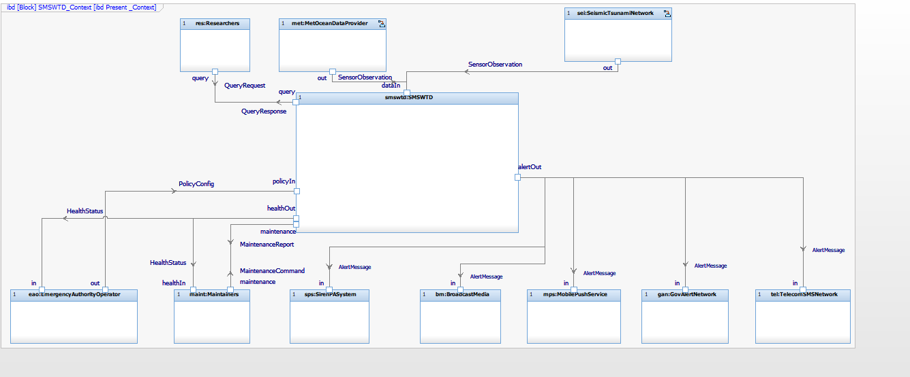

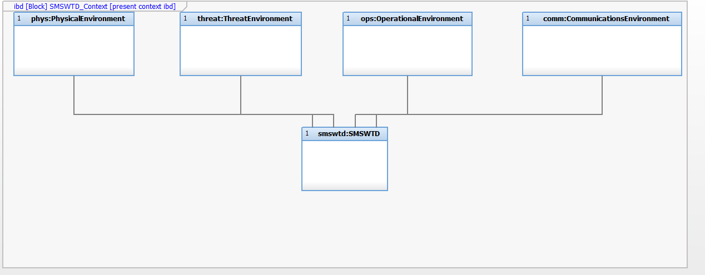

USE CASE & REQUIREMENTS:
This is some of the use cases we came up with and the requirements we derived from them. The highlighted requirements were the ones we were able to accomplish given the time constraints.

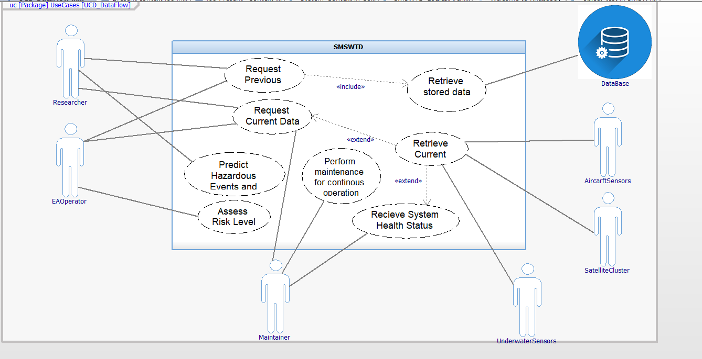
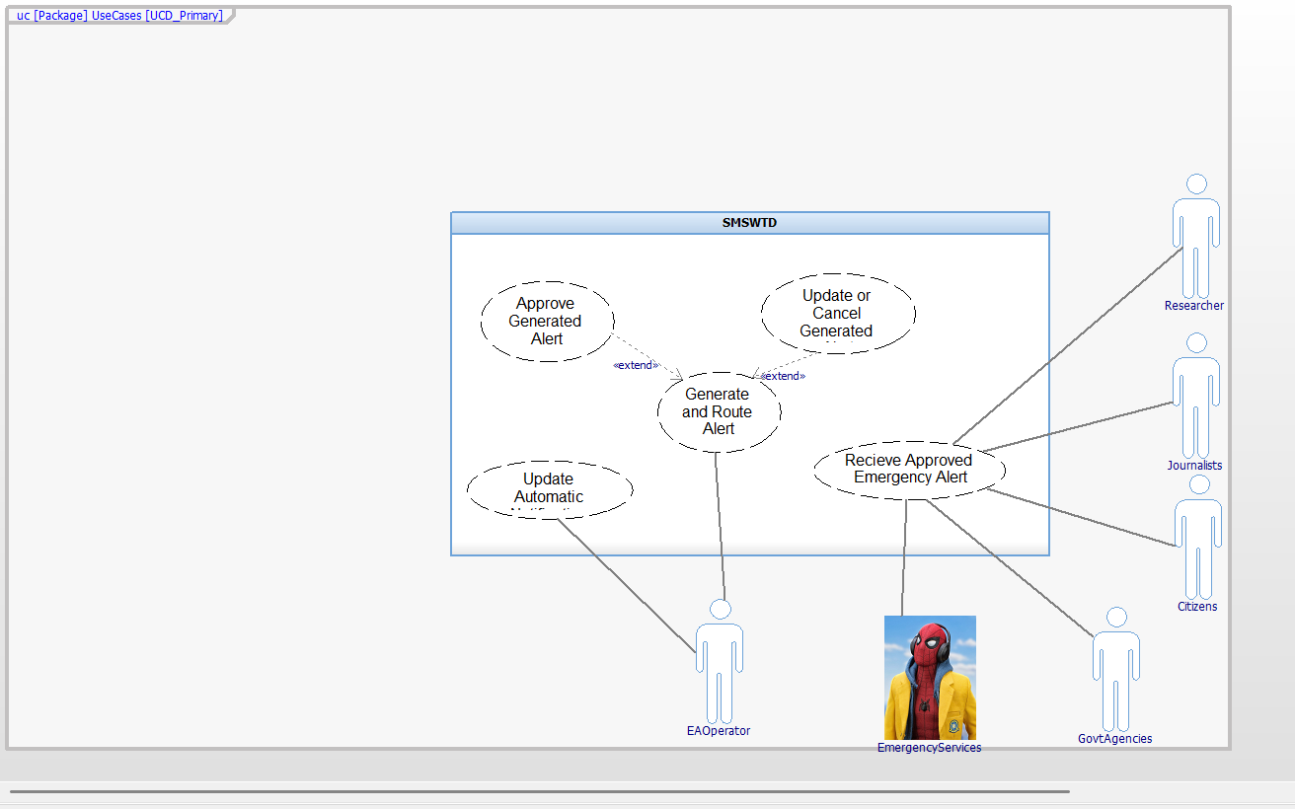
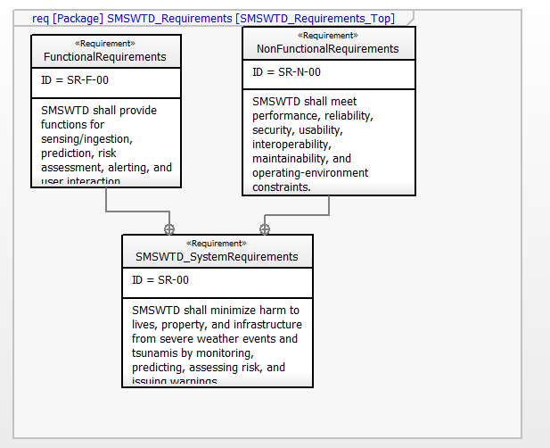

Functional Requirements:
FR-12 FR-03 FR-10 FR-08 FR-17 FR-02 FR-14 FR-09 FR-04 FR-01 FR-05 FR-07 FR-18 FR-06 FR-16 FR-13 FR-15 FR-11
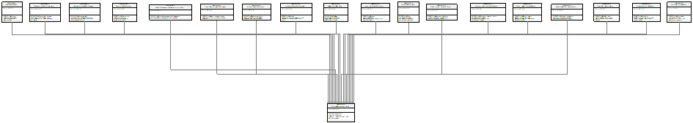
FR-00
Name | Description | Requirement ID
FunctionalRequirements_Detail | Functional requirements supporting monitoring, prediction, risk assessment, and alert dissemination. | FR-00
Ingest_MetOcean_Observations | SMSWTD shall ingest meteorological and oceanographic observations from external providers. | FR-01
Ingest_SeismicTsunami_Observations | SMSWTD shall ingest seismic/tsunami observations from external monitoring networks. | FR-02
Timestamp_And_Synchronize_Data | SMSWTD shall timestamp incoming observations and maintain time synchronization for fusion and event correlation. | FR-03
Validate_And_Qualify_Data | SMSWTD shall validate incoming data and assign data-quality status (e.g., valid/suspect/missing). | FR-04
Fuse_MultiSource_Data | SMSWTD shall fuse meteorological, ocean, and seismic observations into a unified situational dataset. | FR-05
Detect_Hazard_EventCandidates | SMSWTD shall detect severe weather and tsunami event candidates based on fused data and detection logic. | FR-06
Predict_Impact_Zone_And_Timing | SMSWTD shall generate predictions of expected impact zone(s) and timing for detected hazards. | FR-07
Compute_Risk_Assessment | SMSWTD shall compute a risk assessment per affected area based on hazard severity and exposure. | FR-08
Provide_Confidence_And_Rationale | SMSWTD shall provide confidence/uncertainty indicators and rationale for predictions and risk outputs. | FR - 09
Generate_Actionable_AlertMessage | SMSWTD shall generate alert messages that include hazard type, severity, affected area, timing, and recommended actions. | FR-10
Route_Alerts_MultiChannel | SMSWTD shall route alerts to multiple external channels (e.g., SMS, push, government network, broadcast, sirens). | FR-11
Update_Cancel_Alerts | SMSWTD shall support updating and canceling previously issued alerts when conditions change. | FR-12
Track_Alert_Delivery_Status | SMSWTD shall collect and record delivery/receipt status when supported by external channels. | FR-13
Authority_Policy_Configuration | SMSWTD shall accept authority policy configuration (thresholds, escalation rules, alerting policies). | FR-14
Provide_Authority_Dashboard | SMSWTD shall provide a dashboard for authorities to view status, hazards, alerts, and system health. | FR-15
Provide_Researcher_Query_Access | SMSWTD shall provide researchers access to query historical and near-real-time data and outputs. | FR-16
Provide_Maintenance_And_Diagnostics_Interface | SMSWTD shall provide maintainers with diagnostics and maintenance command/report capability. | FR-17
Log_Events_Alerts_And_ConfigChanges | SMSWTD shall log sensor ingestion status, detected events, alerts issued/updated/canceled, and configuration changes. | FR-18

Non-Functional Requirements:
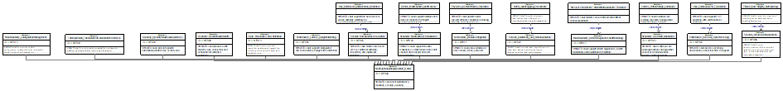
NFR-13 NFR-10 NFR-09 NFR-08 NFR-14 NFR-01 NFR-05 NFR-00 NFR-04 NFR-11 NFR-07 NFR-12 NFR-03 NFR-02 NFR-06

Name | Description | Requirement ID
NonFunctionalRequirements_Detail | SMSWTD shall meet performance, reliability, security, usability, interoperability, and maintainability constraints. | NFR-00
Performance_Latency_BudgetedAlerting | SMSWTD shall support configurable end-to-end latency budgets from detection to alert dissemination. | NFR-01
Performance_RealTime_DataProcessing | SMSWTD shall process incoming observations in near-real-time to support timely detection and forecasting. | NFR-02
Reliability_GracefulDegradation | SMSWTD shall continue core warning functions during partial sensor or communications failures (degraded mode). | NFR-03
Reliability_MultiChannel_Redundancy | SMSWTD shall support channel redundancy so that failure of one alert channel does not prevent alert dissemination. | NFR-04
Security_RoleBasedAccessControl | SMSWTD shall enforce role-based access control for authority, researcher, and maintainer functions. | NFR-05
Security_SecureCommunications | SMSWTD shall protect communications to/from external systems using secure mechanisms (e.g., authenticated/encrypted links where feasible). | NFR-06
Security_Auditability_And_NonRepudiation | SMSWTD shall provide audit logs sufficient to trace alert decisions and configuration changes to authorized users/processes. | NFR-07
Usability_ClearActionableAlerts | SMSWTD shall produce alerts that are clear, consistent, and actionable for intended audiences. | NFR-08
Usability_OperatorSituationalAwareness | SMSWTD shall present operator information prioritized by severity and time criticality. | NFR-09
Interoperability_StandardizedDataAndAlertInterfaces | SMSWTD shall provide machine-readable interfaces for exchanging data and alerts with external systems. | NFR-10
Extensibility_ModularIntegration | SMSWTD shall allow addition of new sensors, feeds, and alert channels with minimal redesign. | NFR-11
Maintainability_RemoteDiagnosticsAndMonitoring | SMSWTD shall support remote diagnostics, health monitoring, and maintenance reporting. | NFR-12
Maintainability_ConfigurationManagement | SMSWTD shall support controlled configuration updates (policies, thresholds, model versions) with traceability. | NFR-13
Data_Provenance_And_Retention | SMSWTD shall retain required records for analysis and traceability, including provenance of data and model outputs. | NFR-14
Comms_PartialOutage_Continuity | SMSWTD shall maintain core warning capability during partial communications outages. | NFR-15
Comms_MultiChannel_AlertDelivery | SMSWTD shall support multiple alert delivery channels to mitigate single-channel failure. | NFR-16
Physical_SensorDrift_IntermittentAvailability_Tolerance | SMSWTD shall tolerate sensor drift and intermittent sensor availability. | NFR-17
Ops_Continuous24x7_Operation | SMSWTD shall support 24/7 operation with shift handover continuity. | NFR-18
Ops_RoleBased_Authorization_Workflow | SMSWTD shall support role-based access and an authority workflow for issuing/updating/canceling alerts. | NFR-19
Safety_AuditLogging_Traceability | SMSWTD shall log alert decisions and configuration changes to provide auditability and traceability. | NFR-20
Threat_DataIntegrity_AntiSpoofing | SMSWTD shall protect the integrity of incoming sensor data and detect spoofing/tampering. | NFR-21
Physical_CoastalOffshore_Operation | SMSWTD shall operate under coastal/offshore conditions including humidity and salt exposure. | NFR-22

SYSTEM LOGICAL ARCHITECTURE:
This is our entire system architecture. The blocks are as follows:
- SensingInterfaceSubsystem : This block takes data from our externals sensors (Seismic Tsunami Network and Meterological and Oceanic sensors) and then determines the certainty of the sensors, and with respect to that either pushes the data forwards to the next stage or sends the most recent data with the appropriate certainty in its place.
- Risk Assessment Subsystem: This block takes the data from the previous state analyzes it and decides the appropriate messages to be created and which entities should be alerted.
- AlertGenerationSubsystem: This block obtains data from the previous block and then pushes the appropriate messages onwards to the appropriate channels.
- DataManagementSubsystem: This would be our internal database that stores all raw and generated data
- UserIntefaceSubsystem: This block is the UI that interacts with external valid users(researchers, emergency authorities, maintainers etc.) These users can then send appropriate requests to the system to execute.
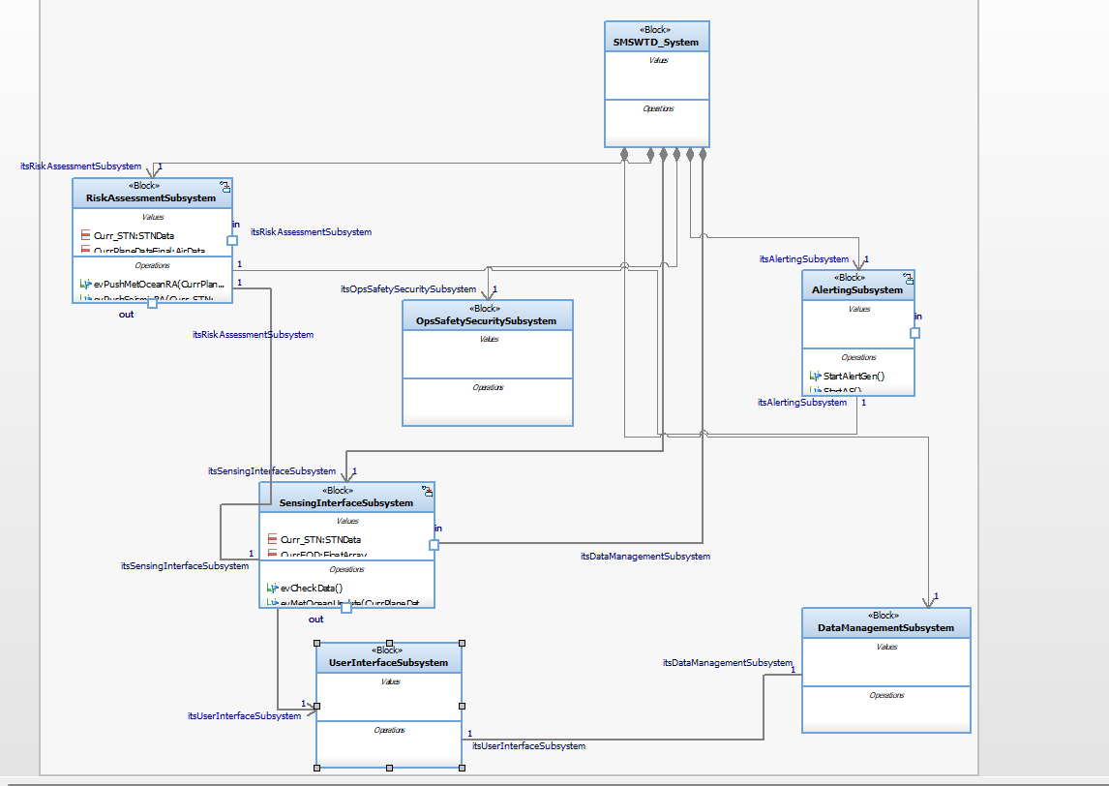
Because of the time constraint, we decided to implement the pipeline of getting raw data from sensors, analyzing their risk and then generating their alerts. The following picture shows the pipeline clearly.
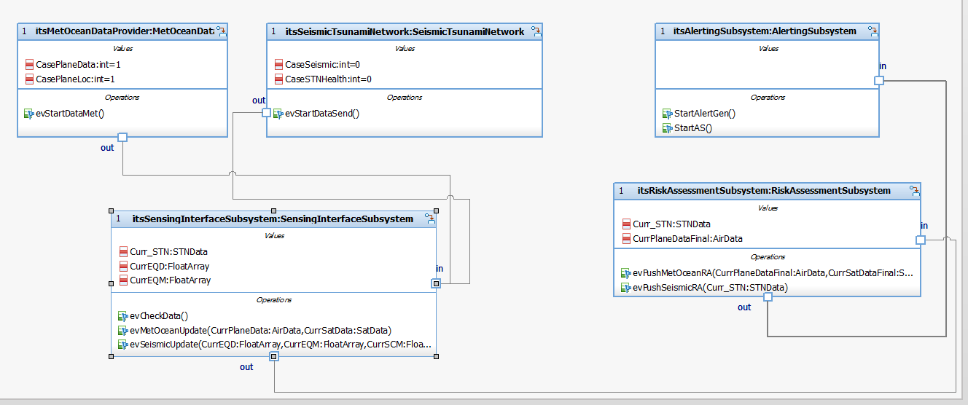
The following statecharts show how the blocks work . MetOceanDataProvider and SeismicTsunamiNetwork as stated previously are the data providers for this reason there statechart is pretty straightforward. In the SendData state they create and send the data for our system to use. In order to make it appear as a realistic system all of our statecharts loop back to either the data creation or data collection state so that they are always waiting or creating data. In order to deal with the latency problems we decided to reduce the delay timer for the subsystem so that it loops back to the collection state as soon as possible. We also increased the the delay for the data providers so that there is no chance that new data is created while the system is still processing the old data. Thus increasing the probability of our system always being ready to receive all the generated data and not miss anything.

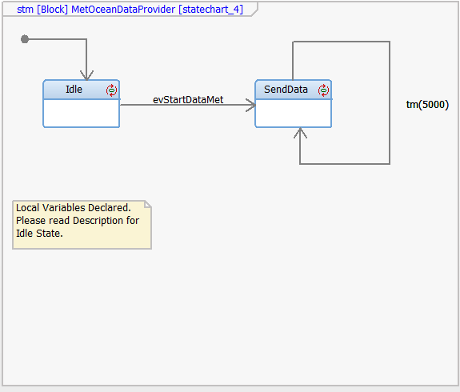
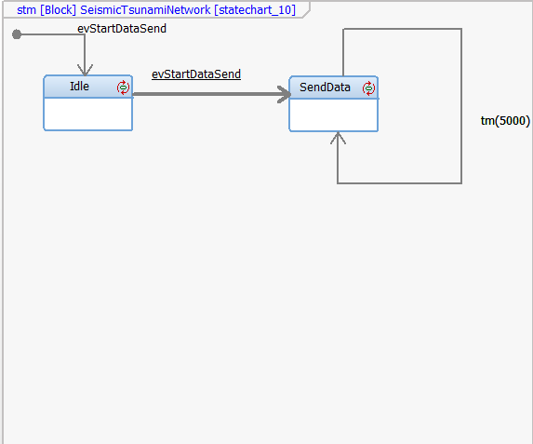
The statecharts for the system while doing different functions have pretty much the same structure. They all have an idle state which is the state when the subsytems are started for the first time. They then have a data collection state where they wait to obtain the data. This state is followed by the functional state, where the core function of the subsystem is executed. In this state there are 2 substates which deal with each specific data provider. This is because we felt that each data provider may have some overlapping data but they are predominantly different from each other. In order to not create confusion or unnecessary confusion we decided to separate into 2 sub states that takes care of each functionality. This also means that both these states independently send data to the next subsystem. In order to ensure cohesiveness and prevent any race conditions we decided that in each collection state the subsystem would not go forward into the next state unless it received assurances that both types of data have been received. Once it receives the signal that both data has been received, it moves forward to the functional state.

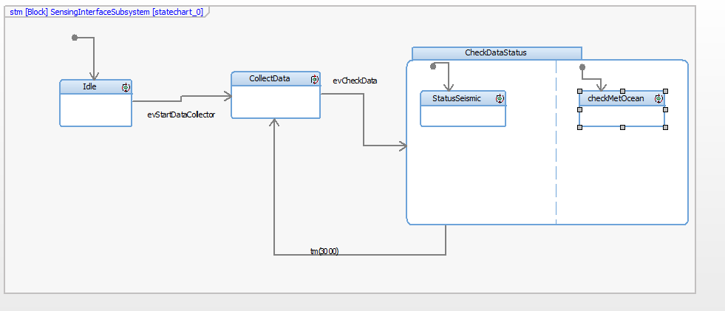

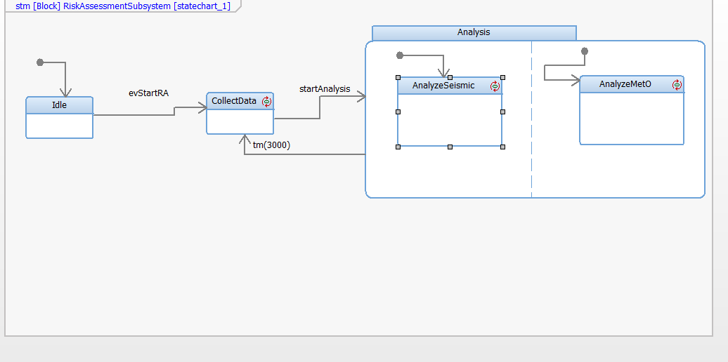

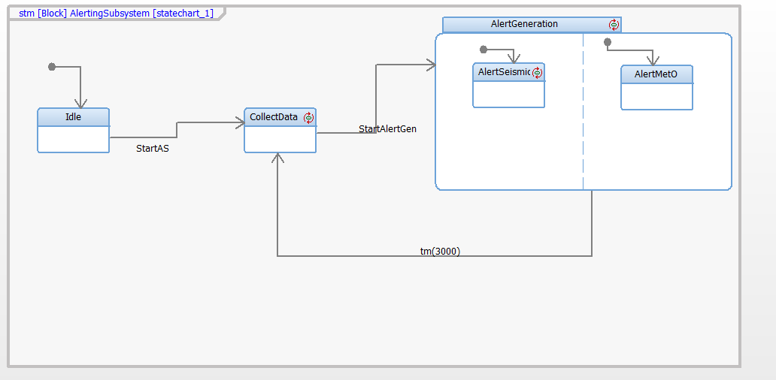
The final 2 diagrams show the panel diagram as the output. In this case we have the inputs which allow us to decide what sort of data we want to generate ( normal data, prediction data and alert data). We have leds which are supposed to simulate that alerts are send to all external entities and what sort of message do they expect to receive as well as any actual text message that goes along with the alert.
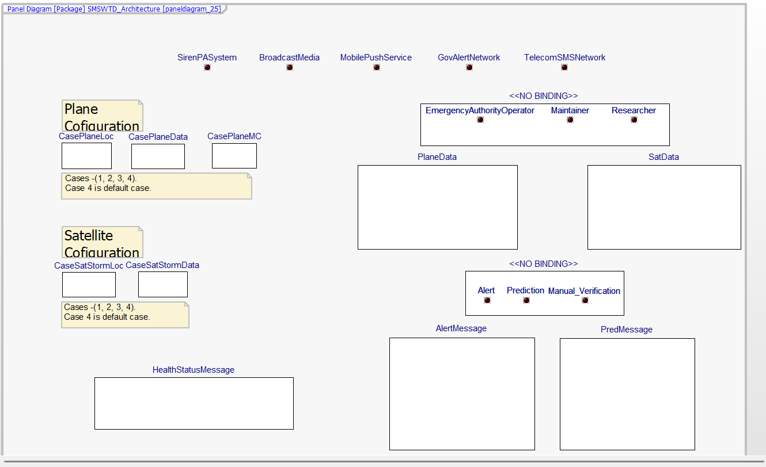
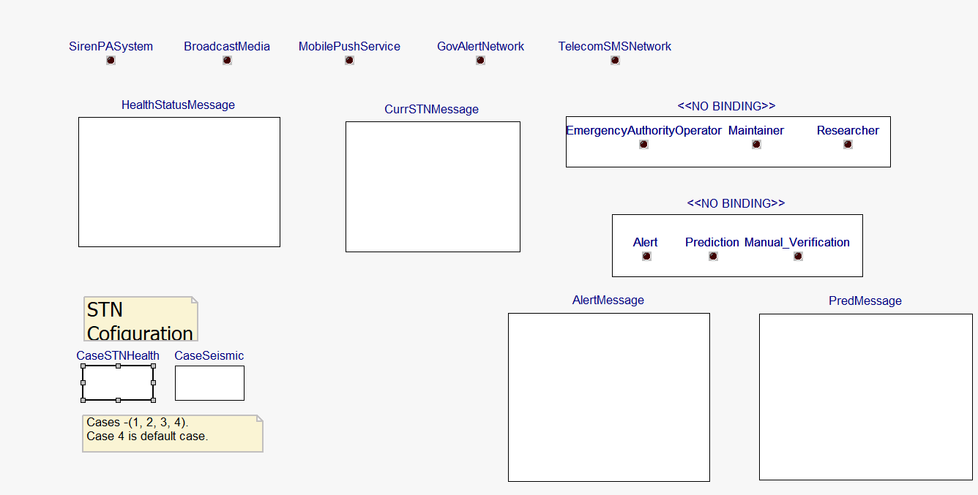

Video Folder link:
SYSML Video

